The Arasaka Corporation is a world-wide megacorporation dealing in corporate security, banking, and manufacturing. It is one of the most influential megacorporations in the world.

The company is also the largest distributor of Japanese-made merchandise throughout the American, European, and Asian markets.

**Arasaka Corporation**

PROJECT COMPUTING PROPOSAL

Michael Inso – ACCP

APTECH QATAR - P00188933

Statement and Confirmation of Own Work

|  |
| --- |
| ***A signed copy of this form must be submitted with every assignment.***  ***If the statement is missing your work may not be marked.*** |

Student Declaration

I confirm the following details:

|  |  |
| --- | --- |
| Candidate Name: | MICHAEL G. INSO |
| Candidate ID Number: | P00188933 |
| Qualification: | L5DC |
| Unit: | COMPUTING PROJECT PROPOSAL |
| Centre: | APTECH QATAR |
| I have read and understood both NCC Education’s *Academic Misconduct Policy* and the *Referencing and Bibliographies* document. To the best of my knowledge my work has been accurately referenced and all sources cited correctly.  I confirm that this is my own work and that I have not colluded or plagiarised any part of it. | |
| Candidate Signature: |  |
| Date: | 9/19/2022 |

**OPS020_dec16_Candidate+Statement+of+Own+Work.doc**

**OPS020_dec16_Candidate+Statement+of+Own+Work.doc**

Acknowledgement3

Introduction of the Company4

Proposal & Technical note: Transport and storage & Advertisement5

Database Entry6

Overview7

References & Bibliography8

Figures:

Figure 1: Relic 6

**Acknowledgment**

This NCC-UK Computing project would not have been possible with hard work and perseverance and account of knowledge and research accumulated in the project.

I am conveying myself of appreciation and acknowledgement to my current computer education school Aptech Qatar. Offering me the astounding opportunity work on this difficult assignments/projects on the title of Arasaka Corporation unit of Computing Project Proposal for NCC-UK Diploma 5 Computing, which also direct me in doing a quantitative of research and analysis of the subject. I also obtained many advance comprehensions, vocabulary, and expertise in computing projects.

Furthermore, I would like to be appreciative of the professor, staff, and the faculties for their great assistance. And additionally, to be indebted to my family who gave me love, support, and accommodation. They aid me a massively in finishing this assignment/project within the narrow span of schedule. The year 2022 was a great distress to all of us because of the global covid-19 pandemic. We hope 2023 would be a pre-eminent year for all of us and all would go back to normalcy.

**Introduction**

The **Arasaka Corporation** (Japanese: **アラサカ社** or **荒坂社**), is a world-wide [megacorporation](https://cyberpunk.fandom.com/wiki/Corporations) dealing in corporate security, banking, and manufacturing. It is one of the most influential megacorporations in the [world](https://cyberpunk.fandom.com/wiki/Earth). The company is also the largest distributor of [Japanese](https://cyberpunk.fandom.com/wiki/Japan)-made merchandise throughout the American, [European](https://cyberpunk.fandom.com/wiki/European_Economic_Community), and Asian markets. Arasaka-branded weapons and military vehicles are among the most sought after by police and security firms. Over the years, it has developed a dark reputation as a corporation that is to be feared and one which covers its tracks using assassins, an army of lawyers, as well as an alleged connection to the [Yakuza](https://cyberpunk.fandom.com/wiki/Yakuza).

The Arasaka Corporation maintains the largest and most powerful armed forces of any corporation in the world, with their guards renowned worldwide and feared by many. Most firms will look to licensing from Arasaka corporate security guards, couriers, or mercenaries to protect their assets. However, Arasaka assets take priority if they are at risk and the troops themselves are loyal to death to the Japanese conglomerate.

Arasaka has made a habit of buying up other companies worldwide, and bleeding out the competition of other Japanese corporations. They also give a heavy amount of support to Japanese communities all over the globe, despite their business practices and overall history being considered unethical.

**Proposal**

My computing project proposal is a **Arasaka Corporation** Website, I’ll be developing a dynamic website with home, landing, product, platform, support, company, and language, donation, social network links, and it’s front-end and back-end code are Java, Javascript, CSS, C, C#, & HTML etc. it would be running in also be using a woff fonts.

We will be using **.jp** domain buying it from Cloudflare since the company is from Japan founded by **Saburo Arasaka**. We will be using Cloudflare to protect against DDOS and penetration tester and illegal hackers.

The company website will be focusing in public crowd offer, venture capitalist, and angel investors. It will be developing the **Relic** is a series of [Arasaka](https://cyberpunk.fandom.com/wiki/Arasaka" \o "Arasaka) biochips allowing the storage and manifested reading of digitized human psyches known as [engrams](https://cyberpunk.fandom.com/wiki/Engram).

**Technical note: Transport and storage**

The **Relic biochip** must be stored and transported in stable thermal conditions and in an appropriate neural environment. Even momentary exposure to temperatures falling outside the recommended range could result in permanent damage to the technology. It is currently recommended to store the Relic device in Arasaka laboratory-certified isothermal containers to ensure a stable storage temperature within 2-8 degrees Celsius (35.6-46.4 degrees Fahrenheit).

## **Advertisement**

*The Relic® : Advanced consciousness-saving technology from Arasaka Corp., packed onto a shard that is the pinnacle of minimalist design. Relic® and The Relic® are registered trademarks of the Arasaka Corporation. Any similarity to products or services that are either extant or in development is purely coincidental. The compilation of personality-construct data and its operative writing to data carriers is a nascent realm of technological, neurological and psychological exploration - results may vary.*

## **Database Entry**

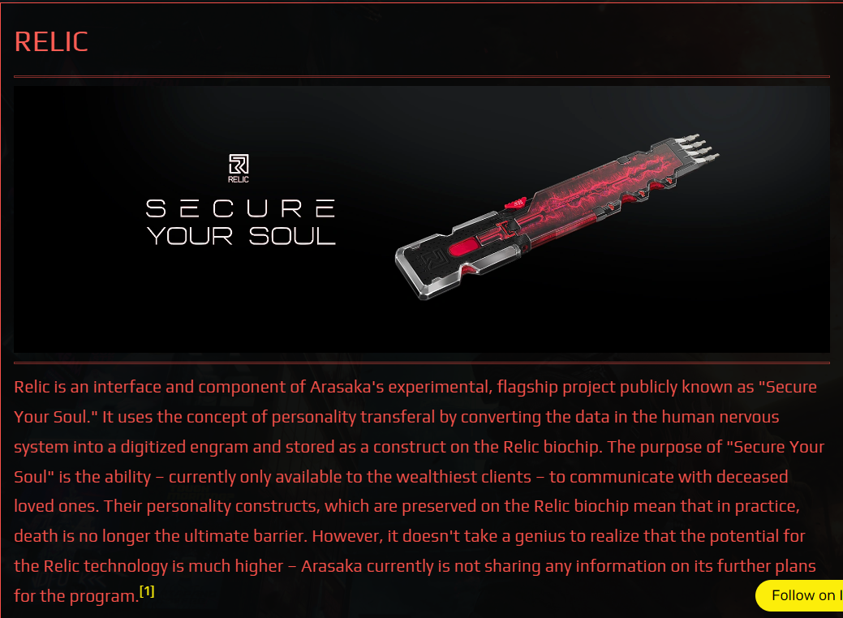

**Overview**

At least two separate versions of the biochip prototype were developed by 2077, according to the [summarized internal report](https://cyberpunk.fandom.com/wiki/Relic_2.0_Prototype_Specifications) assembled by the former director of the Relic project, [Anders Hellman](https://cyberpunk.fandom.com/wiki/Anders_Hellman), upon turning coat for the benefit of Arasaka's rival corporation, [Kang Tao](https://cyberpunk.fandom.com/wiki/Kang_Tao).

The first version was intended for the commercial market and advertised as a means for wealthy elites to store their psyche in form of an engram capable of basic communication with their loved ones. The form itself would have consciousness but lack true self-awareness. In spite of its limitations, Relic 1.0 has managed to enter the market and the lives of [Night City](https://cyberpunk.fandom.com/wiki/Night_City) residents, giving hope by providing a notion of immortality truly approaching human reach. Arasaka logs on the other hand reveal that the Relic's initial purpose was of a more capitalist nature - using [Soulkiller](https://cyberpunk.fandom.com/wiki/Soulkiller" \o "Soulkiller) on celebrities, important cultural icons and artists in order to create engrams for commercialisation purposes.

The second version of the biochip was a top secret project, personally commissioned and supervised by [Saburo Arasaka](https://cyberpunk.fandom.com/wiki/Saburo_Arasaka" \o "Saburo Arasaka). It was intended for internal use within the corporation only, never to be sold. Unlike the original biochip, which was only used to communicate with pre-saved engrams with artificially integrated limitations, Relic 2.0 contains a system which was meant to install and activate the engram in a new organic body. The core idea of the project was to implant a digitized psyche into a new host, although only after the body had all neural and cardiac functions terminated, at which point it would automatically expand into the host's brain using nanotechnology. In short, a person who copied their mind onto Relic 2.0 and then died could be restored to life in a new body using the chip, effectively granting them immortality. Internal testing of Relic 2.0 showed promising results, but Arasaka scientists had difficulty preventing the personality construct from becoming emotionally unstable after re-implantation, and the biochip eventually failed in every trial. The Arasaka Corporation also confirmed that Relic 2.0 would not activate if implanted in living individuals who were on the verge of death. The project had not progressed past the trial phase until an unplanned undertaking of the process by a living individual. Examination of the relic's advancement proved that, despite keeping the subject alive, it was continuing its functional expansion and taking over the motor and psychological functions of the host.

**References:**

**Bibliography**

<https://cyberpunk.fandom.com/wiki/Arasaka#Main_Intent_&_Services>

<https://www.linkedin.com/company/arasaka-corporation/mycompany/>

<https://cyberpunk.fandom.com/wiki/Arasaka>

<https://cyberpunk.fandom.com/wiki/Relic>